Ministry of education and science of Ukraine
National Technical University of Ukraine “Igor Sikorsky Kyiv Polytechnical Institute”
Educational and Scientific Institute
of Atomic and Thermal Energy

Department DCE

Calculation Graphical Work
credit module:
“Visualisation of graphical and geometrical information”

Variant 16

Done by:
student of 1-st course, ІАТЕ
group TR-42mp
Topalova O.E.

Verified by:
Demchyshin A.A
Kalenyk A.S

Kyiv– 2025

Assignment presentation:
- Share the link to your GIThub repo through google form.
- Make sure the repo contains a paper presenting your assignment.
- The practical assignment has to reside in a branch named CGW.

Operations on texture coordinates:
- Scale and rotate a texture around a user specified point.

Requirements:
- Reuse texture mapping from Control task.
- Implement texture scaling (texture coordinates) scaling / rotation around user specified point: odd variants implement scaling, even variants implement rotation.
- It has to be possible to move the point along the surface (u,v) space using a keyboard. E.g. keys A and D move the point along u parameter and keys W and S move the point along v parameter.

Report:
Prepare a digital report that holds:
- a title page;
- a chapter describing the task (1 page);
- a chapter describing theory (2 pages);
- a chapter describing the implementation details (2 pages);
- a chapter of user's instruction with screenshots (2 pages);
- a sample of source code (2 pages).

Variant 16: Virich cyclic surface
Even variants implement rotation.
Theory information about rotation in WebGL

Rotation is one of the fundamental transformations in computer graphics, allowing objects to pivot around a specified axis. In WebGL, a JavaScript API for rendering 2D and 3D graphics, understanding and implementing rotation is essential for creating dynamic and interactive scenes.

Mathematical Background
Rotation in 3D graphics is typically represented using matrices or quaternions.
Rotation Matrices: A rotation matrix is a 3x3 or 4x4 matrix that defines how points in space are transformed when rotated around an axis.
  - For rotation around the X-axis by an angle θ:
[1 0 0 0]
[0 cosθ -sinθ 0]
[0 sinθ cosθ 0]
[0 0 0 1]
  - For rotation around the Y-axis:
[cosθ 0 sinθ 0]
[0 1 0 0]
[-sinθ 0 cosθ 0]
[0 0 0 1]
  - For rotation around the Z-axis:
[cosθ -sinθ 0 0]
[sinθ cosθ 0 0]
[0 0 1 0]
[0 0 0 1]
Quaternions: Quaternions provide an alternative way to represent rotations, avoiding some problems like gimbal lock that can occur with Euler angles. A quaternion for rotation consists of a scalar and a vector. They are often used in WebGL for smooth interpolations (slerp) between rotations.

Implementing Rotation in WebGL
WebGL uses the WebGLRenderingContext to interact with the GPU. To implement rotation, developers typically use GLSL shaders alongside JavaScript. The key steps are:
- Define the Rotation Matrix: In JavaScript, create a rotation matrix using libraries like gl-matrix or manually compute the matrix. Example with gl-matrix:
const mat4 = glMatrix.mat4;
let rotationMatrix = mat4.create();
mat4.rotate(rotationMatrix, rotationMatrix, angle, [0, 1, 0]); // Rotate around Y-axis
- Pass the Matrix to the Shader: Use WebGL’s uniform variables to pass the rotation matrix to the vertex shader.
const uRotationMatrix = gl.getUniformLocation(program, "uRotationMatrix");
gl.uniformMatrix4fv(uRotationMatrix, false, rotationMatrix);
- Apply the Rotation in the Shader: Multiply the vertex position by the rotation matrix in the vertex shader.
attribute vec4 aPosition;
uniform mat4 uRotationMatrix;
void main() {
gl_Position = uRotationMatrix * aPosition;
}

Practical Considerations
- Order of Transformations: When combining transformations (e.g., translation, scaling, rotation), the order matters. Typically, rotation is applied after scaling and before translation.
- Animating Rotation: To create animations, increment the rotation angle over time using JavaScript’s requestAnimationFrame.
- Performance Optimization: Minimize matrix computations by reusing results where possible. Use shaders efficiently to offload computations to the GPU.
The implementation details

1. Texture Scaling or Rotation
The transformation of texture coordinates is handled in the vertex shader. The process involves:
Translation to the origin: Before applying scaling or rotation, the texture coordinates are shifted such that the reference point (user-specified) aligns with the origin.
mat4 getTranslateMat(vec2 t) {
return mat4(
1.0, 0.0, 0.0, t.x,
0.0, 1.0, 0.0, t.y,
0.0, 0.0, 1.0, 0.0,
0.0, 0.0, 0.0, 1.0
);
}
vec4 textureCoordTr = getTranslateMat(-fPoint) * vec4(textureCoords, 0, 1.0);
Transformation (Scaling or Rotation): Based on the variant, either scaling or rotation is applied:
Scaling:
mat4 getTranslateMat(vec2 t) {
return mat4(
1.0, 0.0, 0.0, t.x,
0.0, 1.0, 0.0, t.y,
0.0, 0.0, 1.0, 0.0,
0.0, 0.0, 0.0, 1.0
);
}
vec4 textureCoordTr = getTranslateMat(-fPoint) * vec4(textureCoords, 0, 1.0);
Rotation:
mat4 getRotationMat(float angle) {
float s = sin(angle);
float c = cos(angle);
return mat4(
c, -s, 0.0, 0.0,
s, c, 0.0, 0.0,
0.0, 0.0, 1.0, 0.0,
0.0, 0.0, 0.0, 1.0
);
}
vec4 textureCoordRotate = getRotationMat(fRotation) * textureCoordTr;

Translation Back: The transformed coordinates are shifted back to their original position relative to the reference point.
vec4 textureCoordFinal = getTranslateMat(fPoint) * textureCoordScaled; // Or textureCoordRotate
v_textureCoords = vec2(textureCoordFinal);
These operations ensure that the texture's scaling or rotation happens precisely around the user-defined reference point, creating a smooth and interactive experience.

2. Moving the Reference Point
The reference point (fPoint) is specified in texture coordinate space (u, v). Users can move it using keyboard inputs, allowing interactive control.
Keyboard Handling:
window.addEventListener("keydown", (event) => {
switch (event.key) {
case 'w': point.v += step; draw(); break; // Move up
case 's': point.v -= step; draw(); break; // Move down
case 'd': point.u += step; draw(); break; // Move right
case 'a': point.u -= step; draw(); break; // Move left
default: break;
}
});
Here, point.u and point.v represent the current coordinates of the reference point in (u, v) space.
Passing the Point to the Shader: The updated coordinates are converted into world space and passed to the shader:
gl.uniform2fv(shProgram.iFPoint, [X(point.u, point.v), Y(point.u, point.v)]);

3. Dynamic Updates
Each time the reference point or transformation parameters (e.g., scaling factor or rotation angle) are changed, the scene is redrawn:
function draw() {
gl.uniform2fv(shProgram.iFScale, [scaleU, scaleV]);
gl.uniform1f(shProgram.iFRotation, rotationAngle);

surface.Draw();
}
This ensures that the updates are reflected in real-time, leveraging the GPU for efficient rendering.

4. Example Workflow
- The user presses W or S to move the point vertically along the texture.
  - The point.v value is updated in JavaScript.
  - The new position is passed to the shader through the uniform fPoint.
- The user adjusts the rotation angle with Q and E or scaling factors via UI inputs.
  - Rotation: rotationAngle is updated and passed to fRotation in the shader.
  - Scaling: Values scaleU and scaleV are passed to fScale in the shader.
- The updated texture mapping is calculated in the shader and displayed instantly.

Precision and Smoothness: The implementation ensures precision by using floating-point arithmetic for transformations. The use of GLSL matrix operations minimizes computation errors, providing smooth results for both scaling and rotation.
Real-Time Performance: The GPU handles all transformations, making the operations highly efficient. The redraw mechanism in JavaScript ensures minimal latency between user input and visual updates.
Extensibility: This system can be extended to support additional texture transformations, such as skewing or dynamic mapping, by modifying the shader logic and adding new controls in JavaScript.
The user's instruction with screenshots

Step 1: Launch the Program
- Download the program from the github repository, then open the program in your web browser. Ensure WebGL is supported and enabled in your browser settings.
- The application will display a 3D surface with a texture applied.

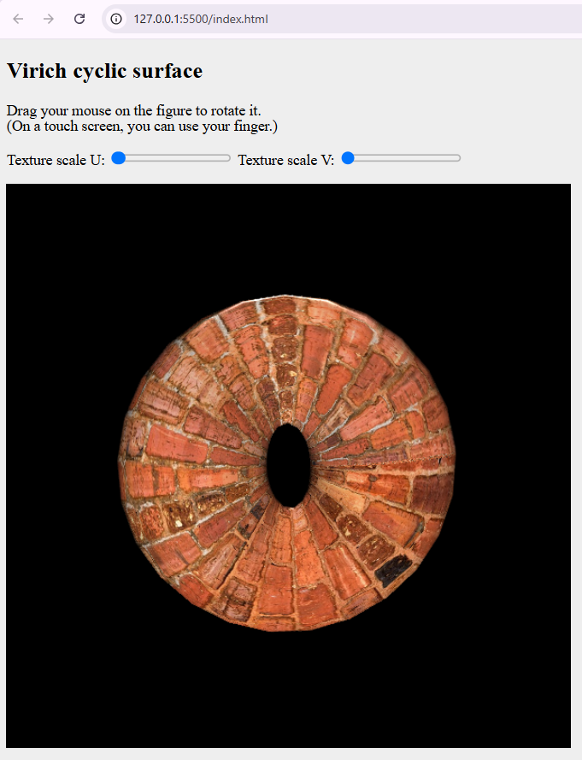
Step 2: Adjust Texture Scaling
To scale the texture around a user-specified point use the input fields labeled "Texture Scale U" and "Texture Scale V" to specify the scaling factors for the horizontal (U) and vertical (V) axes.
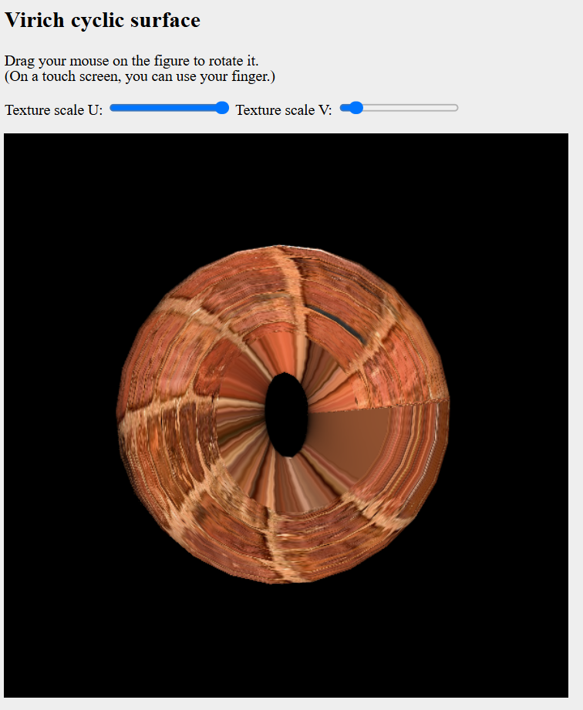

Step 3: Perform Texture Rotation
To rotate the texture around a user-specified point:
- Use the keyboard to adjust the rotation angle:
  - Press Q to rotate counterclockwise.
  - Press E to rotate clockwise.
- Observe how the texture rotates around the reference point specified in (u, v) space.

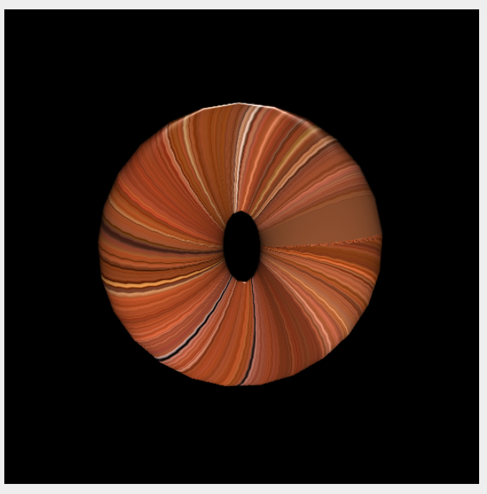
Step 4: Move the Reference Point
To shift the reference point along the surface:
- Usage of the following keys:
  - W: Move the point upward (increase v).
  - S: Move the point downward (decrease v).
  - A: Move the point leftward (decrease u).
  - D: Move the point rightward (increase u).
- The point acts as the center for scaling or rotation, so any transformations will adjust relative to the new location.
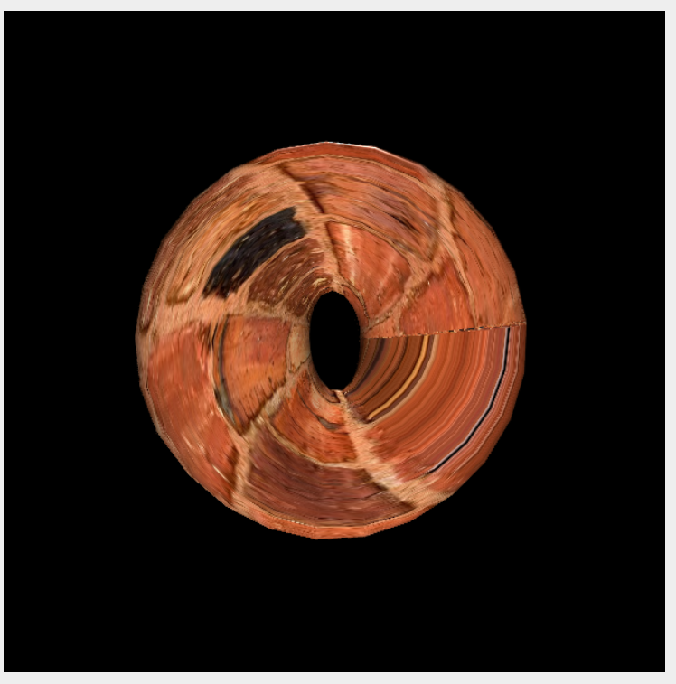

Step 5: Experiment with Dynamic Updates
- Combine scaling and rotation transformations to observe the combined effect.
- Adjust the reference point position dynamically during transformations.
- Experiment with different scaling factors and rotation angles to better understand the program's capabilities.
If you encounter any issues, ensure your browser supports WebGL and that your graphics drivers are up-to-date, also ensure you using Live server while working with program. By following these steps, you can experience the program's functionality for manipulating textures dynamically on a 3D surface.

Code sample

// Vertex shader
const vertexShaderSource = `
attribute vec3 vertex;
attribute vec3 normal;
attribute vec2 textureCoords;

uniform mat4 wInverseTranspose;
uniform mat4 wMatrix;
uniform vec3 LightWorldPosition;
uniform vec3 ViewWorldPosition;
uniform mat4 ModelViewProjectionMatrix;
uniform vec2 fPoint;
uniform float fRotation;

varying vec3 v_surfaceToView;
varying vec3 v_surfaceToLight;
varying vec3 v_normal;
varying vec2 v_textureCoords;

mat4 getRotationMat(float angle) {
float s = sin(angle);
float c = cos(angle);
return mat4(
c, -s, 0.0, 0.0,
s, c, 0.0, 0.0,
0.0, 0.0, 1.0, 0.0,
0.0, 0.0, 0.0, 1.0
);
}

mat4 getTranslateMat(vec2 t) {
return mat4(
1.0, 0.0, 0.0, t.x,
0.0, 1.0, 0.0, t.y,
0.0, 0.0, 1.0, 0.0,
0.0, 0.0, 0.0, 1.0
);
}

void main() {
gl_Position = ModelViewProjectionMatrix * vec4(vertex, 1.0);

vec3 surfaceWorldPosition = (wMatrix * vec4(vertex, 1.0)).xyz;
v_surfaceToLight = LightWorldPosition - surfaceWorldPosition;
v_surfaceToView = ViewWorldPosition - surfaceWorldPosition;
v_normal = mat3(wInverseTranspose) * normal;

mat4 rotationMat = getRotationMat(fRotation);
mat4 translateMat = getTranslateMat(-fPoint);
mat4 translateBackMat = getTranslateMat(fPoint);

vec4 textureCoordTr = translateMat * vec4(textureCoords, 0, 0);
vec4 textureCoordRotate = rotationMat * textureCoordTr;
vec4 textureCoordTrBack = translateBackMat * textureCoordRotate;

v_textureCoords = vec2(textureCoordTrBack);
}
`;

// Fragment shader
const fragmentShaderSource = `
#ifdef GL_FRAGMENT_PRECISION_HIGH
precision highp float;
#else
precision mediump float;
#endif

uniform vec4 color;
uniform vec3 lightDir;
uniform sampler2D tmu;

varying vec3 v_surfaceToView;
varying vec3 v_surfaceToLight;
varying vec3 v_normal;
varying vec2 v_textureCoords;

void main() {
float shininess = 100.0;
vec3 normal = normalize(v_normal);
vec3 surfaceToLightDirection = normalize(v_surfaceToLight);
vec3 surfaceToViewDirection = normalize(v_surfaceToView);
vec3 halfVector = normalize(surfaceToLightDirection + surfaceToViewDirection);

float dotDir = dot(surfaceToLightDirection, -lightDir);
float light = dot(normal, surfaceToLightDirection);
float specular = 0.0;

if (light > 0.0) {
specular = pow(dot(normal, halfVector), shininess);
}

vec4 texture = texture2D(tmu, v_textureCoords);

gl_FragColor = texture * color;
gl_FragColor.rgb *= light;
gl_FragColor.rgb += specular;
}`;

